**Name: Subhapreet Patro**

**Roll No.: 2211CS010547(Sem-ID:33)**

**Group: 7A**

**ADS ASSIGNMENT-1**

**1) Write a program to build a linked list using the built in linked list collection class.  
Ans:**

**Program:**import java.util .*;

class SingleLinkedList{

LinkedList linklist = new LinkedList();

public void add(int item){

linklist.add(item);

}

public int remove(){

return (int) linklist.remove();

}

public void printList(){

System.out.println(linklist);

}

}

public class SingleLinkedListUsingLinkedList {

public static void main(String[] args) {

SingleLinkedList s1 = new SingleLinkedList();

s1.add(10);

s1.add(20);

s1.add(30);

s1.printList();

}

}

**Output:**

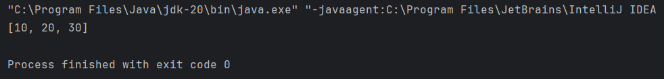

**2) Write a program to implement Doubly Linked List using the built in Linked List collection class**

**Ans:**

**Program:**

import java.util.LinkedList;

import java.util.ListIterator;

public class DoublyLinkedList {

private LinkedList<Integer> list;

public DoublyLinkedList() {

list = new LinkedList<>();

}

public void addFirst(int data) {

list.addFirst(data);

}

public void addLast(int data) {

list.addLast(data);

}

public int removeFirst() {

return list.removeFirst();

}

public int removeLast() {

return list.removeLast();

}

public int get(int index) {

return list.get(index);

}

public void set(int index, int data) {

list.set(index, data);

}

public int size() {

return list.size();

}

public boolean isEmpty() {

return list.isEmpty();

}

public void print() {

for (int i = 0; i < list.size(); i++) {

System.out.print(list.get(i)+"-->");

}

System.out.println();

}

// Method to traverse the linked list in reverse order

public void printReverse() {

ListIterator<Integer> iterator = list.listIterator(list.size());

while (iterator.hasPrevious()) {

System.out.print(iterator.previous() + "-->");

}

System.out.println();

}

public static void main(String[] args) {

DoublyLinkedList list = new DoublyLinkedList();

list.addFirst(1);

list.addFirst(2);

list.addFirst(3);

list.print();

list.removeFirst();

list.print();

list.addLast(4);

list.print();

list.set(1, 5);

list.print();

list.printReverse();

}

}

**Output:**

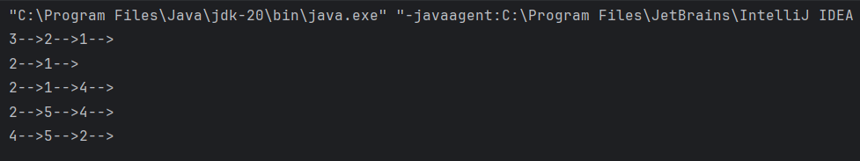

**3) Stack using Linked List (Built in)**

**Ans:**

**Program:**

import static java.lang.System.exit;

class StackUsingLL {

public static void main(String[] args)

{

StackUsingLinkedlist obj = new StackUsingLinkedlist();

obj.push(11);

obj.push(22);

obj.push(33);

obj.push(44);

obj.display();

System.out.printf("\nTop element is %d\n", obj.peek());

obj.pop();

obj.pop();

obj.display();

System.out.printf("\nTop element is %d\n", obj.peek());

}

}

class StackUsingLinkedlist {

private class Node {

int data;

Node link;

}

Node top;

StackUsingLinkedlist() { this.top = null; }

public void push(int x)

{

Node temp = new Node();

if (temp == null) {

System.out.print("\nHeap Overflow");

return;

}

temp.data = x;

temp.link = top;

top = temp;

}

public boolean isEmpty() { return top == null; }

public int peek()

{

if (!isEmpty()) {

return top.data;

}

else {

System.out.println("Stack is empty");

return -1;

}

}

public void pop()

{

if (top == null) {

System.out.print("\nStack Underflow");

return;

}

top = (top).link;

}

public void display()

{

if (top == null) {

System.out.printf("\nStack Underflow");

exit(1);

}

else {

Node temp = top;

while (temp != null) {

System.out.print(temp.data);

temp = temp.link;

if(temp != null)

System.out.print(" -> ");

}

}

}

}  
  
**Output:**

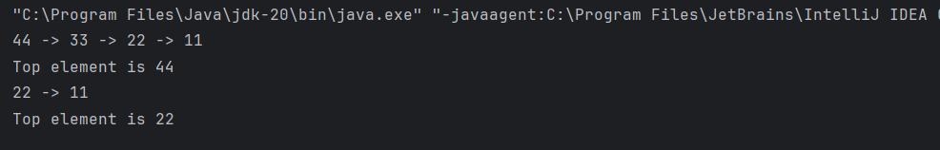

**4) Stacks using Array and ArrayList using generics**

**Ans:**

**(i) Stacks using Arrays:**

**Program:**

class Stack {

static int MAX=100;

int top;

int a[]=new int[MAX];

boolean isEmpty(){

return (top<0);

}

Stack(){

top=-1;

}

boolean push(int x){

if (top>=MAX-1){

System.out.println("Overflow");

return false;

}

else{

a[++top]=x;

System.out.println(x+" pushed into stack");

return true;

}

}

int pop(){

if (top<0){

System.out.println("Underflow");

return 0;

}

else{

int x=a[top--];

return x;

}

}

int peek(){

if (top<0){

System.out.println("Underflow");

return 0;

}

else{

int x=a[top];

return x;

}

}

}

class StackUsingArray{

public static void main(String[] args) {

Stack s=new Stack();

s.push(20);

s.push(40);

s.push(60);

System.out.println("Element popped out: "+ s.pop());

}

}

**Output:**

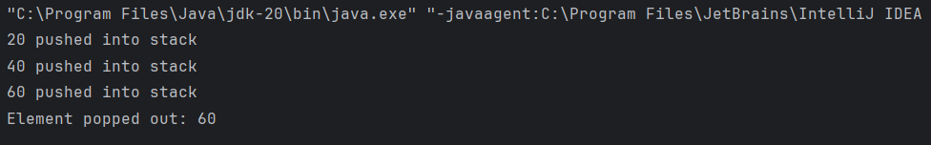

**(ii) ArrayList using Generic Arrays:**

**Program:**

import java.util.ArrayList;

public class ArrayListUsingGenericArrays {

public static void main(String[] args) {

ArrayList<String> strings = new ArrayList<>();

strings.add("?");

strings.add("red");

strings.add("bird");

strings.add("blue");

System.out.println(strings);

ArrayList<Integer> ints = new ArrayList<>();

ints.add(2);

ints.add(3);

ints.add(7);

System.out.println(ints);

}

}

**Output:**

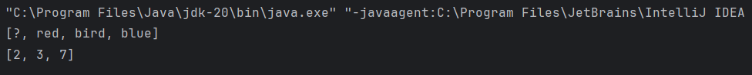

**5) Develop a program to demonstrate the built in arrays class and perform various operations using utility methods for arrays.**

**Ans:**

**Program:**

import java.util.Arrays;

public class ArraysDemo {

public static void main(String[] args) {

// Initialize an array

int[] numbers = {5, 3, 9, 1, 7, 2, 8, 4, 6};

// Print original array

System.out.println("Original array: " + Arrays.toString(numbers));

// Sorting array in ascending order

Arrays.sort(numbers);

System.out.println("Sorted array: " + Arrays.toString(numbers));

// Binary search for an element

int elementToSearch = 7;

int index = Arrays.binarySearch(numbers, elementToSearch);

if (index >= 0) {

System.out.println("Element " + elementToSearch + " found at index " + index);

} else {

System.out.println("Element " + elementToSearch + " not found");

}

// Filling array with a specific value

int[] filledArray = new int[5];

Arrays.fill(filledArray, 10);

System.out.println("Filled array: " + Arrays.toString(filledArray));

// Comparing arrays for equality

int[] arr1 = {1, 2, 3};

int[] arr2 = {1, 2, 3};

int[] arr3 = {3, 2, 1};

boolean isEqual1And2 = Arrays.equals(arr1, arr2);

boolean isEqual1And3 = Arrays.equals(arr1, arr3);

System.out.println("Arrays arr1 and arr2 are equal: " + isEqual1And2);

System.out.println("Arrays arr1 and arr3 are equal: " + isEqual1And3);

}

}

**Output:**

